Review date:
Publication date: | 14th May 2007
Revision: | 0.0
Last saved on: | 15th May 2007
Last saved by: | Jonas Hodel

USRP Fading Simulator - User Guide

Owner: Jonas Hodel and Richard Clarke

Approver(s) - Signature & Date

……………………..……………………………

DEVELOPMENT
TAIT ELECTRONICS LTD

Table of Contents

1 INTRODUCTION 3
1.1 Purpose of Document 3
1.2 Document Conventions 3
1.3 References 3
1.4 Glossary 3
1.5 Document History 3
2 Installation 4
2.1 Server 4
2.2 Client 4
3 Usage 4
3.1 Starting the Server 4
3.2 Client Commands available in Matlab 4
3.3 Caveats 5
3.3.1 Power Control 5
3.3.2 Fading Performance 6
3.3.3 Transmission Stop 7
4 Comparison to the Matlab-ESG Fading Simulator 8
4.1 Straight through Transmission 8
4.2 Fade Rate 8
5 Conclusion 8

INTRODUCTION

Purpose of Document

The purpose of this brief document is to describe how to use the USRP Fading Simulator. This includes installation, usage and potential caveats. Also included is a comparison of the USRPF simulator with the Matlab-ESG fading simulator.

Document Conventions
Place holder

References
Currently foot-noted.

Glossary

Term | Definition
BER | Bit Error Rate
GNU Radio | “GNU Radio provides a library of signal processing blocks and the glue to tie it all together. The programmer builds a radio by creating a graph (as in graph theory) where the vertices are signal processing blocks and the edges represent the data flow between them. The signal processing blocks are implemented in C++. Conceptually, blocks process infinite streams of data flowing from their input ports to their output ports. Blocks' attributes include the number of input and output ports they have as well as the type of data that flows through each. The most frequently used types are short, float and complex.”
USRP | “The Universal Software Radio Peripheral, or USRP, is an extremely flexible USB device that connects your PC to the RF world. The USRP consists of a small motherboard containing up to four 12-bit 64M sample/sec ADCs, four 14-bit, 128M sample/sec DACs, a million gate-field programmable gate array (FPGA) and a programmable USB 2.0 controller. Each fully populated USRP motherboard supports four daughterboards, two for receive and two for transmit. RF front ends are implemented on the daughterboards.”
USRPF | USRP Fading Simulator
UUT | Unit Under Test

Document History

Date | Version | Comment
 | 0.0 | First Draft

Installation

This section covers the installation of both the Server and the Client.

Server

At the time of writing the server was already setup. These instructions will only apply if the USRP computer needs to be re-setup. These instructions apply to Ubuntu Edgy.

- Install and setup GNU Radio and the Tait Gnu Radio code base (please refer to the installation section of “Using GNU Radio.pdf” available at P:\technology\GNU Radio and USRP\Tait Docs.
- To allow user access to the USRP, setup the USB permissions by following the instructions available at http://viral.media.mit.edu/wiki/tiki-view_blog_post.php?blogId=3&postId=37.
- Setup an FTP server by following the instructions at http://ubuntuforums.org/showthread.php?t=79588. Note that the actual FTP sever chosen does not matter. Simply, an agreed file location between the server and the client must exist. The client sends files to this location and when requested, the server expects to find files for playback in this same location.

NB: The above websites have been archived and can be found at C:\...\GnuRadio\USRP Fading Simulator\Documentation\Archive.

Client

The client can be written in any language but in this implementation the client was written for Matlab. To begin using the USRPF client:

- Check out the code from the SVN repository http://svnhost.tait.co.nz:3180/svn/research/RadioTerminals/Tools/GnuRadio/trunk.
- In Matlab set the path to include (with subfolders) C:\....\GnuRadio\USRP Fading Simulator\Client.

Once the client has been setup all functions will be usable from within Matlab.

Usage

Starting the Server

Before attempting to communicate with the server, the server program needs to be started on the USRPF server computer. The server program “USRP_Fading_Simulator_Server.py” is located in C:\.....\GnuRadio\USRP Fading Simulator\Server. To start the program:

- On the server computer open a terminal.
- Navigate to the location above.
- Type “./USRP_Fading_Simulator_Server.py”.
- The server will report that it is waiting for a connection.

Client Commands available in Matlab

The command set described in Table 1 has been developed to allow for scripted control of the USRPF, from within Matlab. Note that the server will only accept ‘set’ commands when playback is not active. For further details refer to the inline documentation available within the code.

Command | Function
USRPF_open_connection | Opens a connection with the USRPF server. Do not call this again before the connection has been closed.
USRPF_close_connection | Closes the connection to the sever and frees it for usage by another client.
USRPF_set_rf_tx_freq | Sets the RF transmission frequency of the USRP.
USRPF_set_rf_tx_power | Sets the RF transmission power of the USRP. The RF output power control of the RFX400 is very poor, thus control is poor at best.
USRPF_set_rf_tx_sample_rate | This relates to the sample rate of the source file. When using an RF source this parameter does not need to be set.
USRPF_set_recv_speed | This affects the amount of Raylegh fading that is applied to the sourced samples. If the speed is set to zero then fading is disabled. This is useful when straight through transmission is required.
USRPF_send_file | Sends a file to the server using FTP
USRPF_play_file | This begins transmission and fading of samples sourced from a file.
USRPF_play_receiving_rf | This begins transmission and fading of samples sourced from received RF.
USRPF_play_stop | Stops transmission. The execution time for this command is four seconds.
Table 1: Command set available within Matlab.

Caveats

This section outlines caveats and highlights limitations of the USRPF Fading simulator.

Power Control

There are three gain stages that can be used to control the RF output power, as illustrated in Figure 1.

Rx Gain:
0 – 65 dB
Software Multiplier:
±2¹⁵
Tx Gain:
Must be fixed 20 dB
Figure 1: Gain stages.

The USRPF_set_rf_tx_power function works by adjusting the software multiplier. The affect of this multiplier was investigated by using the RSSI measurement capabilities of a TP9100 to produce the results seen in Figure 2.
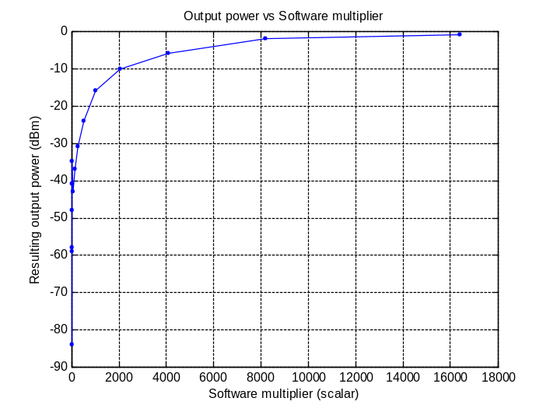
Figure 2: Effect of software scalar on output power.
Based on the measured results, Figure 3 was also produced and the following relationship was derived:

p_{o} = 18*log10(s_{x}) – 73,

where p_{o} is the output power in dB and s_{x} is the software multiplier. This relationship is only an approximation for values between 0 and -40 dBm.
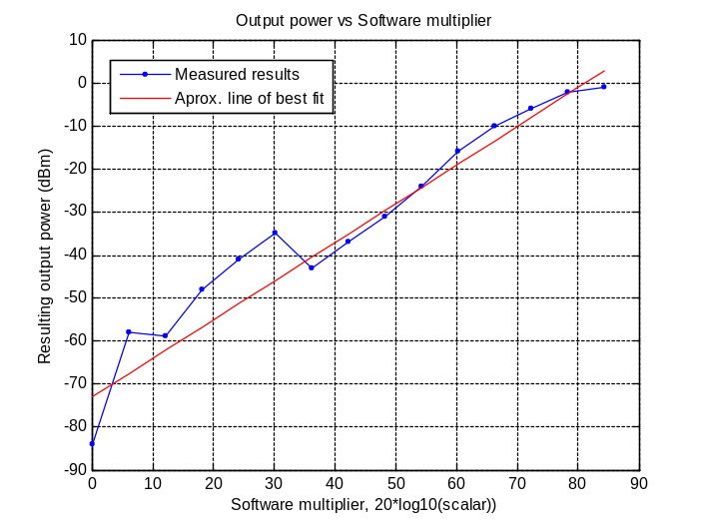
Figure 3: Quantifying the effect of the software multiplier on output power.

This experiment is by no means conclusive and a more detailed analysis of the affect of the software multiplier on output power should be carried out.

If the RF performance of the RFX-400 transmitter (the USRP daughterboard that was used for these tests) is not sufficient then a possible alternative is the use of the LFTX board. This board can provide a signal generator with an external complex base band modulation source. By using a signal generator to modulate and transmit the provided complex base band samples, much finer control of the RF transmission is possible.

Fading Performance

The Rayleigh fading algorithm [], which has been integrated into GNU Radio, was benchmarked to determine whether it meet TIA specified theoretical limits. The measured and theoretical Level Crossing Rate (Figure 4) and Cumulative Probability Distribution Function (Figure 5) were compared. The fading algorithm meets specifications for both. However, the distortions introduced by the USRP transmitter may mean that the specifications are no longer satisfied when the faded profile undergoes transmission.

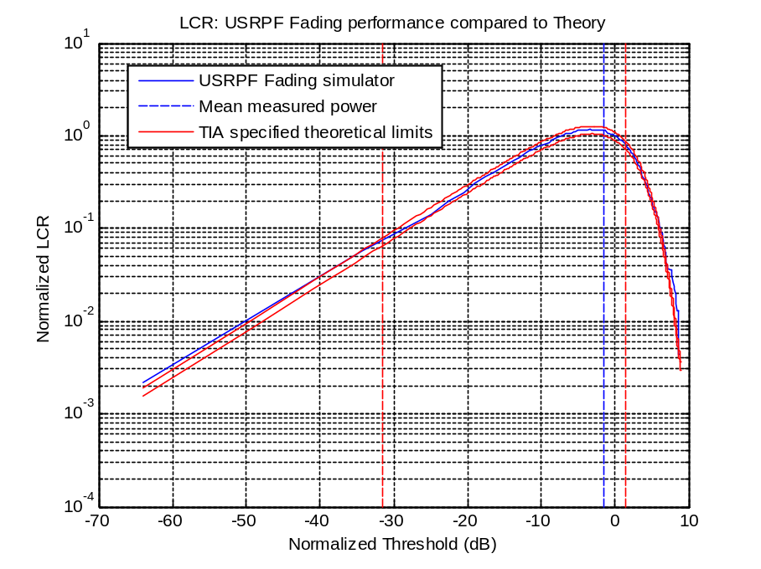
Figure 4: USRPF fading performance compared to TIA specifications for LCR.
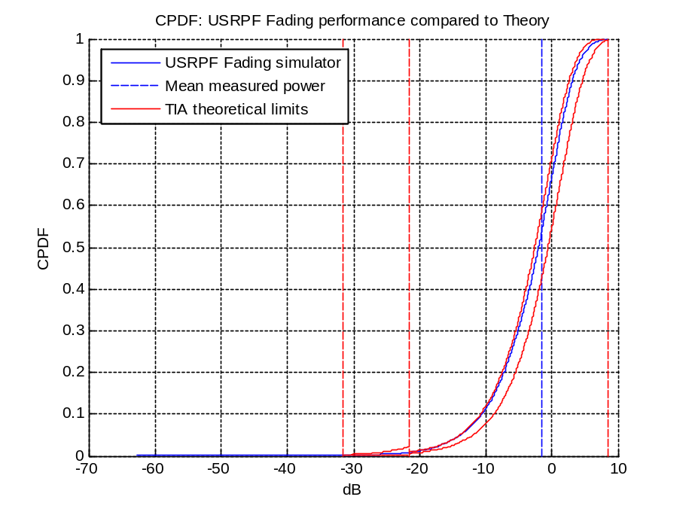
Figure 5: USRPF fading performance compared to TIA specifications for CPDF.

Transmission Stop

Under normal conditions, the USRPF RF transmission can stop in one of two ways. Either the file source has exhausted all samples, or the user has instructed the server to stop play back. To give the USRP time to recover, the playback stop process takes approximately four seconds. Thus, when writing scripts that pause after initiating playback (long enough for file playback to finish), add four seconds to the pause time. Alternatively, call USRPF_play_stop() before the file source is exhausted. This function call will automatically block for four seconds.

Comparison to the Matlab-ESG Fading Simulator

The Matlab-ESG Fading Simulator is used to transmit Matlab faded profiles to the UUT. To gain an idea of the USRPF Fading simulator’s performance, relative to the Matlab-ESG, results generated by the two simulators were compared.

Straight through Transmission

In this experiment the same test was carried out, first using the Matlab-ESG and then the USRPF (refer to “USRPF_C4FM_BER_vs_delay_spread.m” located at C:\....\GnuRadio\USRP Fading Simulator\Client\Examples for details. Fading on the USRPF was disabled so that straight through transmission of the Matlab generated and faded waveform could occur. The results are shown in Figure 6.

TODO: RUN TEST, GET RESULTS, PLACE HERE.
Figure 6: Matlab-ESG and USRPF comparison with fading disabled.

Fade Rate

In this experiment the BER vs Fade Rate was measured first using the Matlab-ESG and then the USRPF fading simulator. In addition, results from the Rhode & Schwarz Fading simulator are also included. The results produced are illustrated in Figure 7.

TODO: RUN TEST, GET RESULTS, PLACE HERE.
Figure 7: Matlab-ESG and USRPF comparison for BER vs Fade Rate.

Conclusion

Due to limitations of the USRP hardware fading performance is limited to functional testing only. The Rayleigh Fading algorithm meets TIA specifications, but distortions introduced by the USRP transmitter means that the transmitted profile is unlikely to conform to the standard.

Mention results on comparison of Matlab-ESG

The server client frame work that has been established can be used as a platform for further development of USRP Fading simulator capabilities.

http://www.gnu.org/software/gnuradio/doc/exploring-gnuradio.html#intro
http://www.gnu.org/software/gnuradio/doc/exploring-gnuradio.html#usrp
C. Komninakis, "A Fast and Accurate Rayleigh Fading Simulator", in IEEE Globecom 2003, GC01-8, Vol. 6, p. 3306-10, San Francisco, CA, December 1-5, 2003.

